Girl Scout
Howard County Day Camp
PO Box 1817; Ellicott City, MD 21041
http://www.gshcdc.org gshcdaycamp@gmail.com

GENERAL
INFORMATION

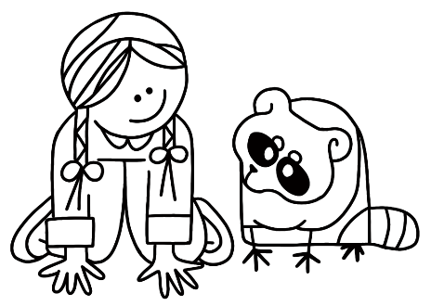

You have registered for:

Session One: June 26-30, 2023

Welcome to Girl Scout Howard County Day Camp!
Our all-volunteer staff looks forward to having your
Girl Scout participate in an exciting outdoor program
at Temple Isaiah in Fulton, Maryland.

The following information is provided to help you plan for a
happy and successful camping experience.

Camp Hours

The camp week is Monday through Friday from 9:00 am until 3:30 pm. Camp runs rain or shine.

Each campsite is equipped with a large dining canopy. In case of thunderstorms or very heavy rain, there is a large building at the camp that will accommodate the campers.

Cancellations or delays due to severe weather or other emergencies will be announced on radio station WBAL (1090 AM). Please note that there can be no refund of camp fees under these circumstances.

Camp Schedule

The camp day begins at the bus stop, where the campers are picked up and driven to the camp on a standard school bus. On the first day, prior to boarding the bus, the campers will be given a color-coded name badge and bus button with a special design for each bus. The campers are required to wear the button all day.

Arriving at camp, campers will match their name tag color with the colored flags on the field. There will be several adults and older Girl Scouts to welcome the campers and assist any girl who needs help finding her unit.

Each morning begins with a flag ceremony at the flag circle. After a full day of activities and fun, the camp again gathers at the flag circle for closing and dismissal. So that no one is left behind, we have all campers line up according to the different design on their bus button. All names are checked before boarding the buses and heading home.

Transportation

Each camper is assigned to a specific bus. You will be notified in June to confirm your child’s assigned bus stop and pick-up/drop-off times. The schedule will not be determined until the end of the school year, when the bus company can make test runs of the routes. Since buses from other camps may be using the same bus stop, it is critical that you do not put your child on a bus if her name is not on the bus roster. If a camper’s name is not on a roster, please call the camp.

Please arrive at the bus stop about 10 minutes earlier than the designated time, both in the morning and afternoon. A parent or authorized childcare provider must remain with the camper until she is safely on the bus. This is your responsibility, not the Day Camp’s. If your camper misses the bus, the caregiver may drive the camper to Temple Isaiah. Come to the far left corner of the parking lot, where you see our banner, and check in with the staff there.

Since most buses will stop at more than one stop, it is critical that your camper know, by name, the stop she is supposed to use. Practice the bus stop name with your camper several times in the days before camp so that she will recognize her stop. Bus monitors will help when needed and they will announce each stop as the bus arrives at a drop-off point. An adult or authorized childcare provider must meet each camper on time at the end of each day. It is not the camp’s responsibility to assure that an adult is there for every child when they are let off at the bus stop. Please inform the camp immediately, if a bus lets children off
earlier than the designated time.
A written permission note to the attention of the Transportation Director is required if a camper’s transportation plans change. If you need to pick up your child before the end of the camp day, notify the Transportation Director and come to the shelter near our banner, at the far left corner of the parking lot.

Program Theme

While the camp theme changes each year, general camp activities include crafts, songs, games, dance, hiking, outdoor cooking and swaps.

Specialty Days—generally applies to the shirt worn each day at camp. Participation is widely observed, but optional.

Monday Girl Scout t-shirt day—wear a camp shirt from a previous year, any Girl Scout shirt, or a shirt in Girl Scout colors

Tuesday New camp t-shirt day—wear the new camp t-shirt, which is distributed on Monday.

Wednesday Dress as your camp name OR dress in patriotic colors, red-white-blue

Thursday Unit choice day—decided in each unit, possibly theme related or wear your unit color

Friday New camp t-shirt day—same as Tuesday

Shirt signing is a very popular, but optional activity at camp on
Friday. If your child would like to have her t-shirt signed by her fellow campers, Program Aids and Unit Leaders, the shirt should first be laundered. A permanent marker should accompany her to camp on Friday.

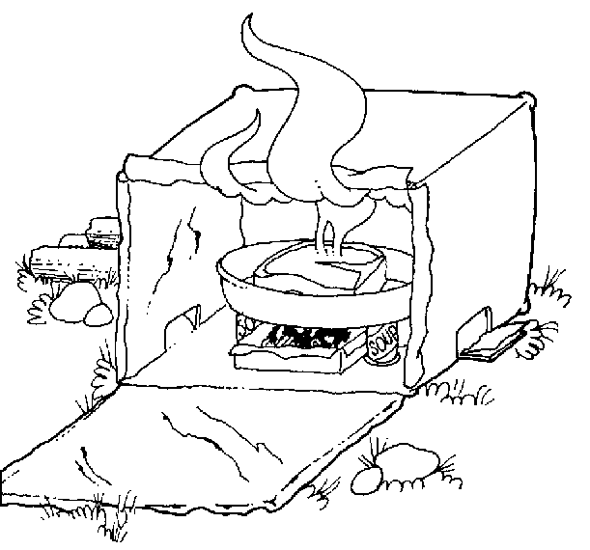
Cooking Day

All campers will have one cookout at camp. On this day, lunch will be provided. Your camper will need to bring a mess kit or unbreakable plate, silverware and, if possible, a dunk bag (mesh bag with string attached, usually used for washing lingerie). These items will only be needed on Cooking Day.

Your camper will bring home a letter on Monday to let you know which day she will be cooking out—please look for this letter and only pack a snack and drink on that day.
What To Wear

- Hat or scarf that covers the head—not just a visor
- Shirt that covers the shoulders and tummy
- Sneakers with socks that cover the ankle—no shoes with open toes or sling-back heel, sandals or flip-flops
- Shorts that fall to mid-thigh or lower are more comfortable for camp activities

What To Bring

- Sit-upon
- Water bottle or canteen—filled at home
- Lunch, snack and 2 drinks in appropriate containers—insulated lunch bag with ice pack preferred
- Bandana—bring two if one is to be worn as the head covering
- Rain gear—poncho, rain/mud boots and extra socks These items are recommended if conditions warrant bringing them. Note: a poncho is cooler in the heat and can cover camper’s pack as well
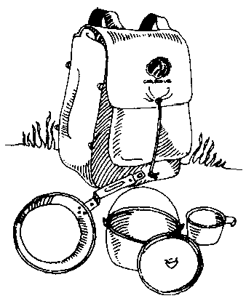
- Sunscreen—apply before camp each day
- Insect repellent—non aerosol and no more than 13% DEET
- Facial tissues—optional
- Chap stick—optional
- Cooking Day supplies—see Cooking Day

These items are readily available at local sporting goods stores, Dick’s, Walmart, Target, etc.

All clothing and possessions should be labeled with the camper’s name. A hip/fanny pack is handy for carrying small items and a daypack is most helpful to keep the child’s belongings together.

Things To Leave at Home

- Jewelry and other valuables
- Electronic devices—cell phones, mp3 players, games, etc.
- Gum and candy

Sanitation and Safety

Sanitation arrangements are provided via portable potties. Hand wash units are available at each station and in each camper unit.

Adult staff is trained in emergency procedures, and most units have at least one adult trained in First Aid. At least one camp nurse is available at all times.

Campers are instructed to stay on camp paths to avoid possible contact with poison ivy and ticks, and should be checked for ticks each evening. Campers can protect themselves by following camp rules on clothing and using camp paths.

Medical Information

All medications must be given to the camp nurse in the original prescription container on the first day of camp and must be accompanied by a written note from the parent with specific instructions on how and when to administer.

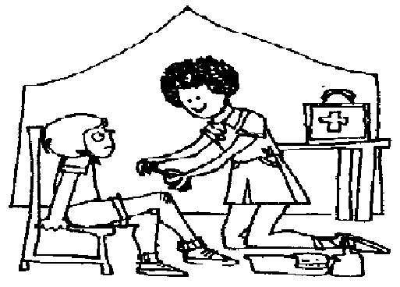
Medications must be kept and distributed by the nurse with the exception of asthmatic inhalers and bee sting allergy kits. Campers with either of these items are requested to bring two, so that one may be kept by the camper and the other by the camp nurse.

Please notify camp if your camper cannot participate in a certain type of activity or is ill and will not be attending camp that day. Please do not send an ill child to camp.

Camp Telephone: Will be posted on GSHCDC Website

The phone will be active one week before camp and one week after camp. While camp is in session, the phone will be answered from 8:00 am through 4:30 pm. You may leave a message on the answering machine after camp hours. Please notify the camp if your child will not be attending camp on a specific day. The camp staff is dedicated to providing a positive outdoor experience for your camper. If you have any questions or concerns, please contact us as early as possible.
Camp Visiting Period

Campers and their families may come and visit camp, on the Sunday prior to the scheduled session, for a self-guided tour. Drop by and look around from 2:00 pm to 3:00 pm. Please drive slowly in the parking lot.

Camp Name

Girl Scout tradition includes the use of camp nicknames. Please help your camper think of a camp name, and a second choice, to use for the week. Helpful hints include favorite activities, sports, foods, storybook characters, heroes, birds, animals, her name spelled backwards, etc.

Our number one priority is the safety of the campers. We ask that everyone understand and follow the rules and procedures outlined in this booklet along with those communicated during the camp week.

Our next priority is to ensure that your camper experiences the fun, relationships, and education provided by our dedicated camp staff
and the variety of activities offered.

See you at camp!

Special Projects

Prepare for Success

Each year, GSHCDC collects school supplies for the Prepare for Success program to help students in Howard County.

Campers may bring supply items to camp Tuesday through Friday to be collected at the opening flag ceremony, and they will be awarded a ribbon for their Unit Flag.

Please ask your camper not to open any sealed packages brought to camp, e.g., do not open a pack of pencils so that the Unit can receive more ribbons.

Thank you for your help and generosity.

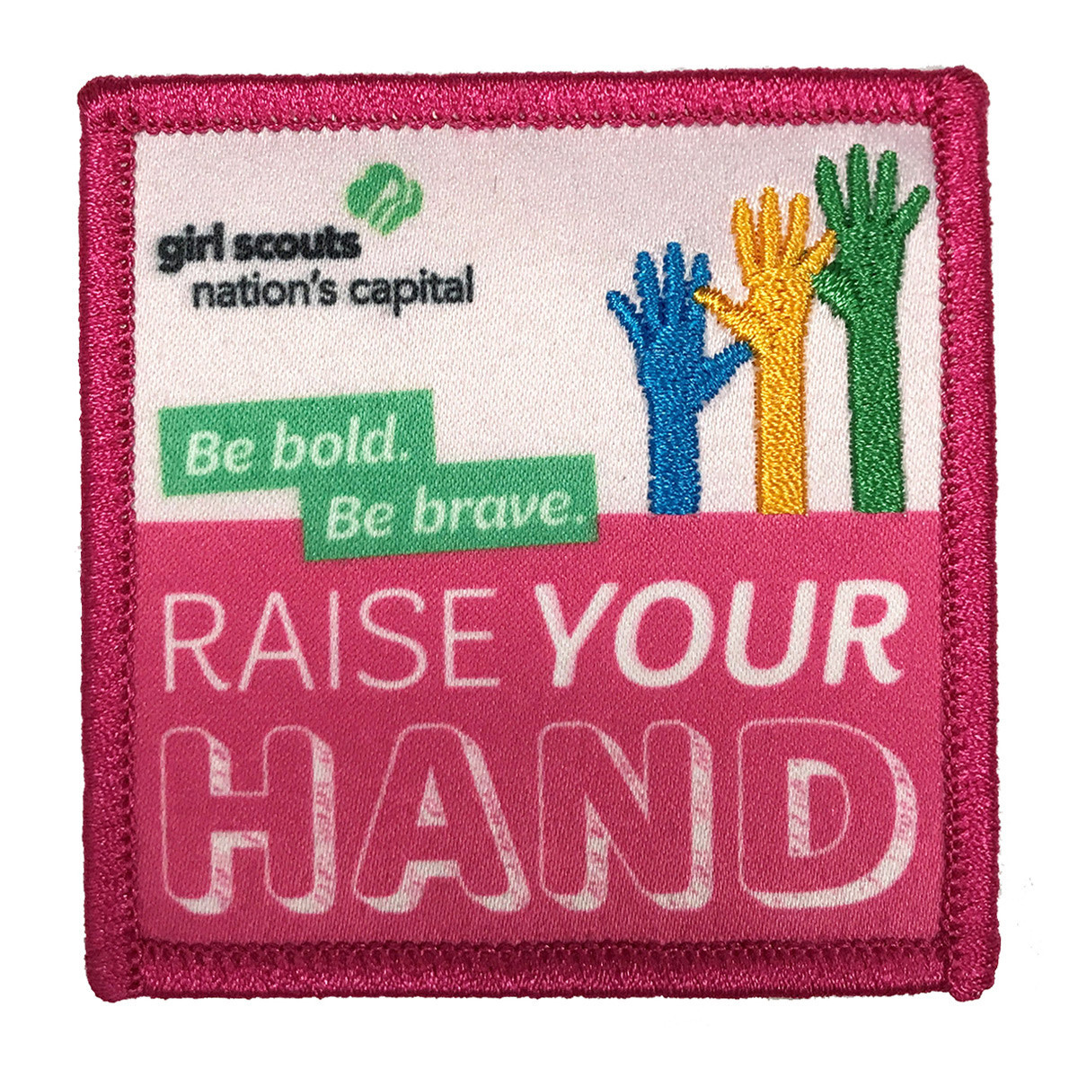
Raise Your Hand Patch Program

Campers will have the opportunity to participate in “Raise Your Hand” activities while at camp.

Additional activities can be extended at home or
with a troop, if desired. The patch can be purchased at https://www.girlscoutshop.com/GSCNC-Raise-Your-Hand-Patch

Girl Scout
Howard County Day Camp

