How to Use an Epipen
An EpiPen is an epinephrine auto-injector used to treat a severe allergic reaction called anaphylaxis. Anaphylaxis is potentially fatal and is considered a "treat first, then call for help" medical emergency. Epinephrine is a synthetic version of naturally occurring adrenaline created by the body. A single dose of epinephrine, properly administered, is extremely low risk. Proper, timely use of an EpiPen can save the person's life.
Part 1
Identifying The Symptoms Of Anaphylaxis
- 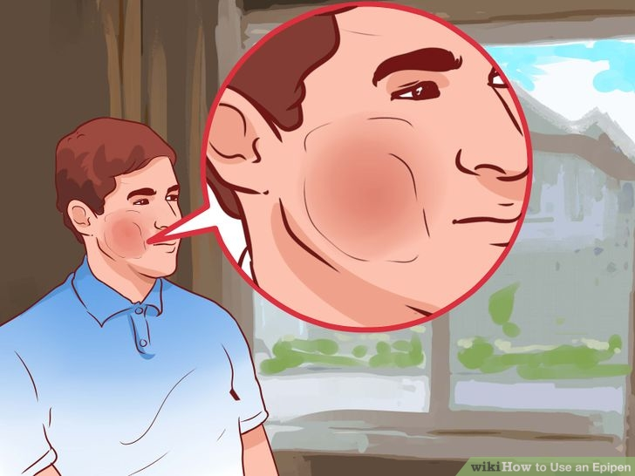

Identify the symptoms. Anaphylaxis can occur when a person is accidentally exposed to a known allergen, but it also can occur when a person is exposed to an allergen for the first time. It is also possible to become sensitized to an allergen, that is, to develop allergies to things that previously did not cause a reaction. In some cases the reaction can be so severe it can be life threatening. Look for the following symptoms:^{[1]}
  - Flushing of the skin
  - Rash on the body
  - Swelling of the throat and mouth
  - Difficulty swallowing and speaking
  - Severe asthma
  - Abdominal pain
  - Nausea and vomiting
  - Drop in blood pressure
  - Collapse and unconsciousness
  - Confusion, dizziness or an "impending sense of doom"

Ask the person if they need help to use their EpiPen. Anaphylaxis is considered a 'treat first' emergency. If the person knows they need an injection and can instruct you then help them first. The instructions for the EpiPen are printed on the side of the device.
- 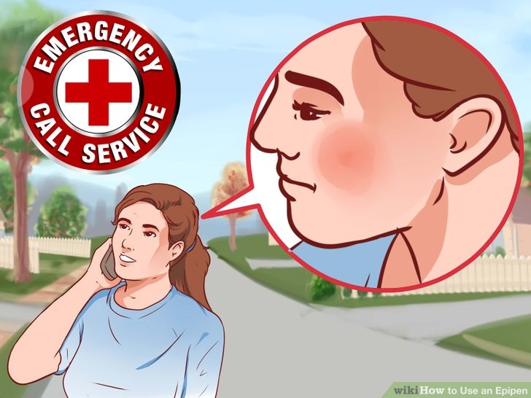

Call emergency services. Even when using the epinephrine/adrenaline, it's still imperative to have professional help as soon as possible.
  - Always have your country's emergency number on your phone.
  - Tell the operator your location before anything else, so help can be sent immediately.
  - Describe the condition and the emergency to the operator.
- 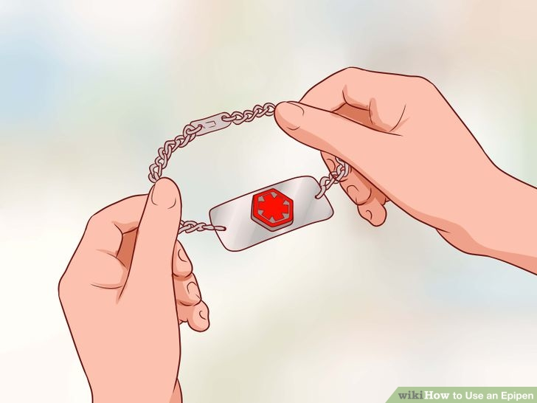
Check for a medical ID necklace or bracelet. If you suspect a case of anaphylaxis in someone else, look for a necklace or bracelet. People suffering from severe allergies usually carry those in case of an accident.^{[2]}
  - These necklaces and bracelets detail the condition and give additional information on health.
  - They usually bear a Red Cross sign or other easily recognizable visual clues.
  - If you suffer from severe allergies, always carry the instructions with the EpiPen. That way, if you are incapacitated and someone else has to administer it, they'll know what to do.
  - Don’t give the EpiPen to someone suffering from a heart condition unless they have their own based on a doctor's prescription.^{[3]}

Part 2
Using the Epipen
- 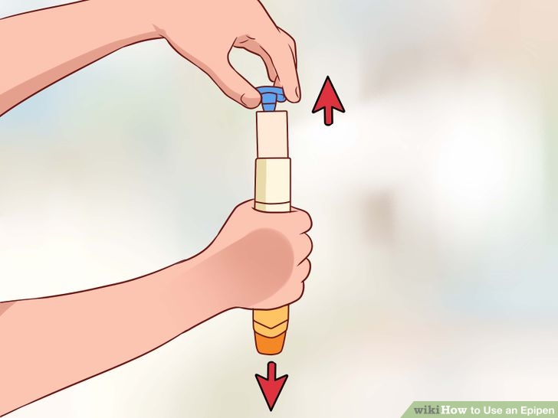
Hold the EpiPen firmly with your fist in the middle. Do not put any part of your hand over either end to avoid an accidental trigger. An EpiPen is a single-use device; once it is triggered it cannot be re-used.
  - Avoid placing your finger over either end to avoid accidentally triggering the device.
  - Pull off the blue activation cap (opposite end from the orange tip that holds the needle).^{[4]}
- 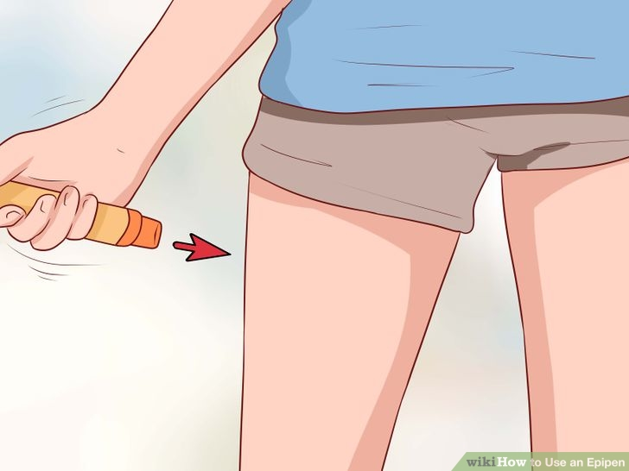
Inject into the mid-outer-thigh. Place the orange tip against the thigh and push firmly. There should be a click once the needle has entered the thigh.^{[5]}
  - Hold for several seconds.
  - Do not inject in any other place than the thigh. Accidental intravenous injections of adrenaline can lead to death.^{[6]}
- 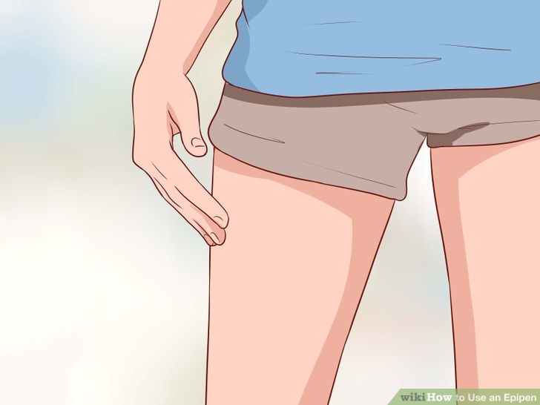
Remove the EpiPen. Remove the unit and massage the injection area for 10 seconds.
  - Check the tip. The orange needle cover should automatically cover the injection needle once the EpiPen is removed from the thigh.
- 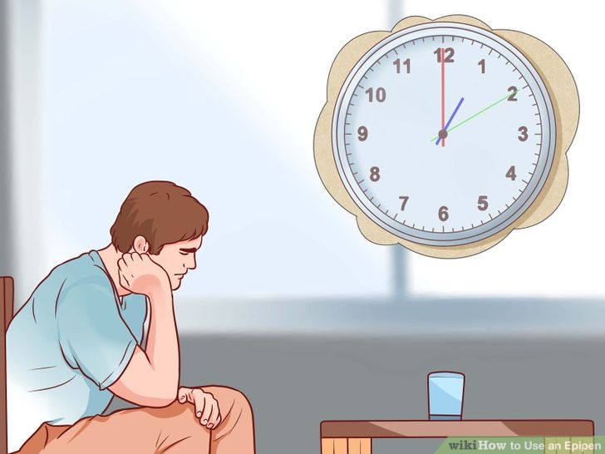

Prepare for possible side effects. When you give a person an EpiPen, it may cause them to feel panicked or paranoid, and can also cause their body to shake uncontrollably. This is NOT a seizure.
  - The shaking will subside over the next few minutes or hours. Don't freak out; just try to be calm and reassuring. Your calm will help to settle the person.

Go to the hospital immediately. 20% of acute anaphylaxis episodes are quickly followed by another crisis, called biphasic anaphylaxis. Once you have administered or received the EpiPen, you should be seen by a doctor without delay.
  - The second episode might be mild or severe. If not treated, it can lead to a fatality.
  - The second crisis happens when patients seem to have recovered. It’s important to go to the hospital even if you feel fine.

