How to Identify Poison Ivy, Oak, and Sumac
By Sarah Densmore
There’s nothing like a long nature hike to relieve stress and invigorate your soul. There’s also nothing like a woodland landscape to put you at risk for coming into contact with one of summer’s greatest skin irritants – poison ivy, oak, or sumac.
If you’re a tenderfoot, you may not know what these three plants look like. But when it comes to communing with nature, ignorance is not bliss. Within 12 to 72 hours of touching any one of these plants, you could develop a very uncomfortable, itchy, and unsightly red rash accompanied by swelling and blisters.
The itch-inducing ingredient in all three is urushiol. It’s an oil that’s contained in the plants’ leaves, stems, and roots. Urushiol sticks to anything it touches. So if you pet your dog or hop on your bike after they’ve brushed up against a poison oak shrub, you could end up with a rash. In addition, if someone is burning the plants and you’re close by, airborne urushiol can land on your skin and cause an itchy breakout.
Poison ivy, oak, and sumac grow in most regions of the country. Here’s what to look for — and steer clear of — when you’re out amongst the plant life.
- Poison Ivy: The trademarks of this plant are its solid green, pointed leaves that hang from the stem in groups of three. It grows as both a vine and a shrub. The look of poison ivy can change with the seasons. It produces yellow-green flowers in the spring and its green leaves can change to yellow and red in autumn.
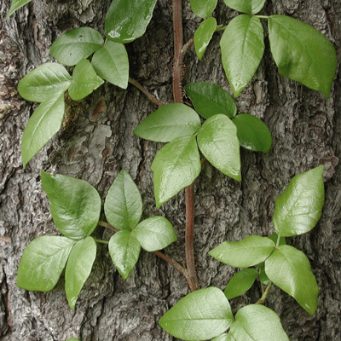
Images courtesy of www.poison-ivy.org
- Poison Oak: Like its ivy counterpart, poison oak leaves also cluster in sets of three. The edges of the solid green leaves, while reminiscent of an oak tree, are less dramatic. Poison oak is most often seen in shrub form, but it can also grow as a vine.
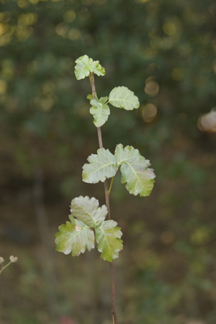
When it comes to identifying poison ivy and oak, a quick rule of thumb is: Leaves of three, beware of me.
Poison Sumac: This rash-producer thrives in the water. It’s usually found in swampy or boggy areas where it grows as small tree or tall shrub. Poison sumac leaves can have urushiol-filled black or brownish-black spots. The leaf stems contain seven to thirteen leaflets.
