FIRE SAFETY

Before starting the fire:
- Gather fire-building materials after morning flag ceremony:
  - Red Shed - Rake/shovel, buckets, sprinkle can
  - Fill buckets with water from pump
  - Quartermaster – matches
  - Firewood in firebox, gather additional by patrol
  - Fire starters - optional
- Go over Fire Safety with girls when patrols have returned from their first caper.
- Place metal bucket containing water in fire circle. Place stick to be used as poker in fire bucket to soak.
- Properly dressed – no scarves, lanyards, nylon clothing. Long hair needs to be tied back or under a hat.
- Only two campers in the fire circle at one time and they must have business there (cook, fire tender). Others may sit on benches around the fire circle. [For very young or forgetful campers, you may have them straddle the log.]

Building the fire:
- Clear fire circle of debris and low hanging branches.
- Use safe fuels to start the fire. NO paper products, leaves or flammable liquids.
- Make sure water buckets are filled and next to fire ring before lighting fire
- Never leave the fire unattended. Make sure an adult or PA is stationed at the fire at all times. Rotate for breaks.

Using the fire:
- If clothing should catch fire, STOP, DROP to the ground, and ROLL! Never run!
- Adult, or PAs, should stay with the fire at all times.
- Use hot pads or mitts when handling utensils.
- Never pour grease on/in the fire, lit or unlit.
- Do not reach over the fire.
- Step over fire circle logs, never on them.
- No flaming sticks leave the fire circle. (s’mores)

Putting out the fire:
- Sprinkle lightly with water. Do not dump large quantities of water on the fire. Soak large logs in the bucket.
- Stir the embers with the stick, then sprinkle with water. Repeat until the fire is out and you can hold your hand over it and not feel any heat.

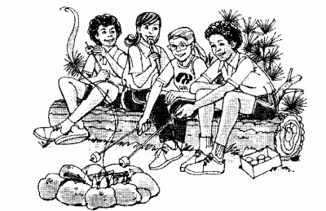
FIRE BUILDING

Site Preparation:
- Clear fire circle of debris and low hanging branches.
- Gather fire-building materials:
  - Red Shed - Rake/shovel, buckets, sprinkle can
  - Fill buckets with water from pump
  - Quartermaster – matches
  - Firewood in firebox, gather additional by patrol
  - Fire starters - optional
- Note weather forecast and gather adequate amounts of tinder, kindling and fuel for fire the day before or the morning of Cooking Day. Cover fuel if rain is expected.
- Fill metal fire bucket with water and place in fire circle. Place stick to be used as poker in fire bucket to soak.
- Make sure metal grate will move into desired position before starting fire.

Gather Wood:
- Wood fires needs 3 different kinds of fire material:
  - TINDER: material that burns as soon as it is touched with a match. It should be in pieces not any thicker than a match, but longer. Wood shavings or fuzz sticks, small twigs (especially from evergreen trees), bundles of tops of bushes or weeds, pieces of fat pine or thin pieces of bark (from dead trees) make good tinder. Beware of light material like grass or leaves that flare up quickly but have little real substance and burn out too quickly to catch anything heavier on fire. You may want to store some of your tinder in a covered coffee can to keep it dry.
  - KINDLING: good dry sticks and twigs graduated in size from pieces just bigger than tinder up to pieces as thick as a thumb, and from six to twelve inches long. Larger pieces may be split for kindling. Kindling must be thin enough to catch fire quickly before the tinder burns out, but large enough to ignite the larger fuel. Sticks should snap when broken. Dead branches from the lower limbs of trees which are still standing or are off the ground make excellent kindling.
  - FUEL: fuel is the larger wood that keeps a fire going. Good, firm pieces of wood graduated in size from pieces just bigger than kindling up to good-sized logs, depending on use. Fuel might be charcoal or dry, seasoned wood found on the ground. Wood that crumbles is rotten and will just smolder and smoke without giving off heat when burned. Don't use it. At some sites, it may be necessary to bring fuel with you.
- Avoid green or rotten wood. Do not break living branches off trees or bushes.
- Gather more wood than you think you’ll need, especially Tinder. Check firebox for Fuel-sized wood and plan accordingly. It is proper Girl Scout etiquette to restock the fire box.

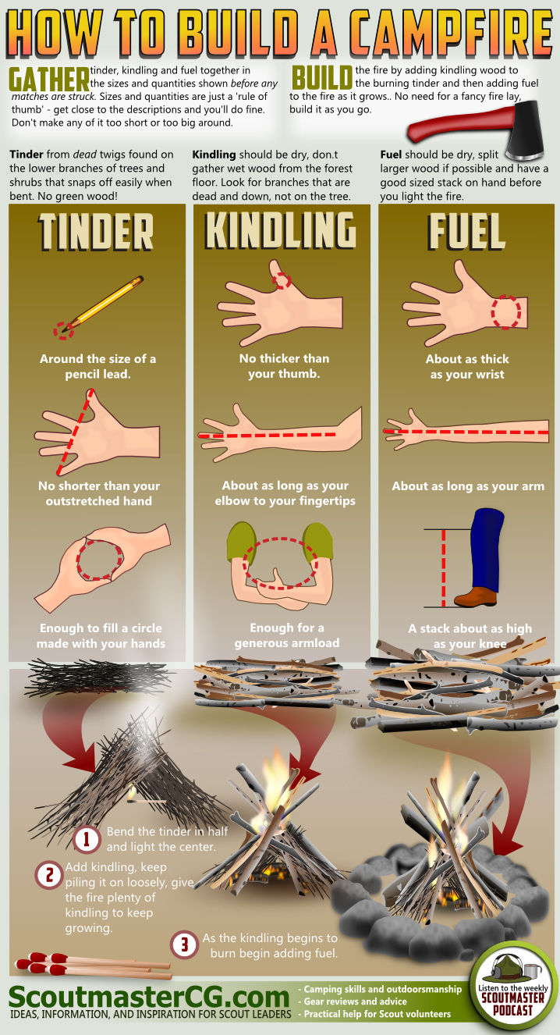
Lighting the Fire:
- Kneel with your back to the wind. Choose your style of campfire layout e.g. linear, frame, etc. and build with fire starter, tinder and kindling.
- Strike the match close to the wood. ALWAYS STRIKE AWAY FROM YOUR BODY. Hold the match beneath the tinder until the flame burns up through. Then place additional tinder and kindling onto the fire. Place each piece of kindling separately. Remember to have enough extra tinder, kindling and fuel within close reach.
- Especially if wood is damp, plan to use a fire starter(s).
- Fire needs oxygen to burn. Place the pieces of wood close enough so that one piece of burning wood will light the adjoining pieces but leave enough space between pieces of wood so that air circulation is not cut off. Once the kindling is burning, add fuel. Do not make any sudden changes in size of wood used; add pieces that are just a bit larger than those already burning. Use just enough fuel for cooking needs. The size of the fire should be no bigger that the bottom of your largest cook pan.
- LIQUID FIRE STARTERS ARE PROHIBITED!
- The type of meal will determine when you need to start the fire. Long-cooking items, such as baked potatoes or things cooked in cast iron, need coals, which means an earlier start. The Quartermaster’s meal plan will advise
- NEVER LEAVE THE FIRE UNATTENDED!

Extinguishing the Fire
- Pull fire apart with stir stick
- Sprinkle with water. Do not dump entire bucket into fire ring.
- Fire is out when you can place the back of your hand very close to the ashes and they are no longer warm.
- Return clean equipment to their place of origin.

Working with Girls – Let Them TRY:
- If you plan to have girls light matches, arrange with Quartermaster a day ahead, or bring your own additional matches.
- Making fire starters is an optional activity. [Note: using dryer lint for fire starters is not an approved method.]

